*A Tale of 3 Countries: A Story of comparative education systems in 10-11 graphs*

Overview: The data for this project come from a source known as EdStat. Once again, agglomerated from and by the World Bank. Here, we focus on the most present, continuing, and mappable trends over time. And hope to acquire more data, and gather more insights, as time progresses!

1: Unemployment Rates, total population

A very interesting trend noted in the unemployment trend below is how strongly US markets respond to a global economic crisis. While the epicenter of the crisis was in the US, the response in other heavily invested trade partners seems relatively calm in comparison. The snap back in recovery is equally impressive!

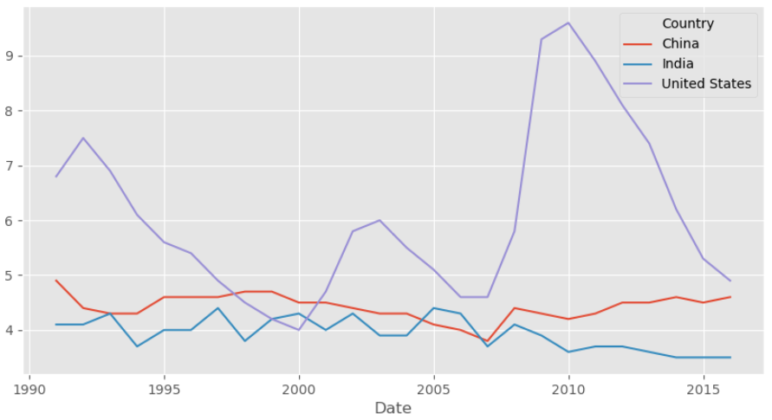

2: Internet Users over time

This, perhaps is my favorite trend. The US, as a pioneer of internet technology, was not only quick to adapt. It did so exponentially in the early years. Thereafter, leaving China, and India to play catch up. Whereas, India and China have been showing promising signs in recent years, the US hovers above 70% of its population as internet users, with China above 50%, and India having cross the 30% mark.

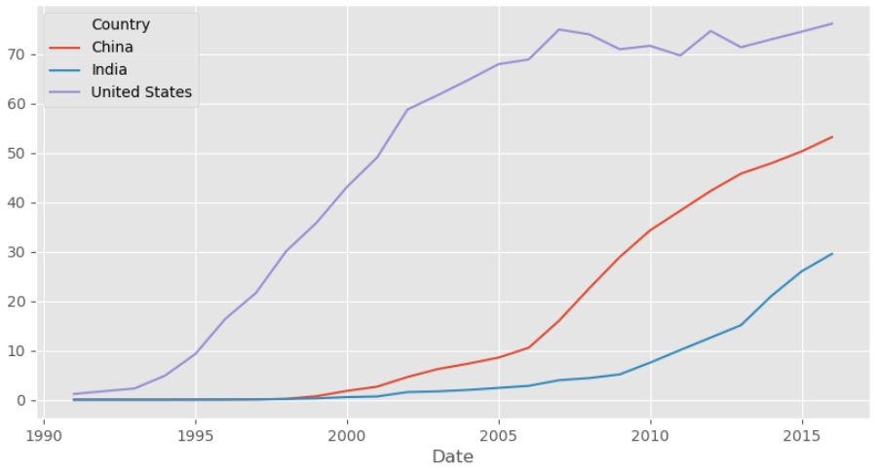

3: Female Labor Force

One of the more depressing trends, we see India’s already disparate genders separating more, as the women in the workforce participating actively dips even further. China and the US’s workforce participation remains steady at 45% of the working age population for women. What this signifies is a need for a cultural shift – one of the stickier aspects of cultural change.

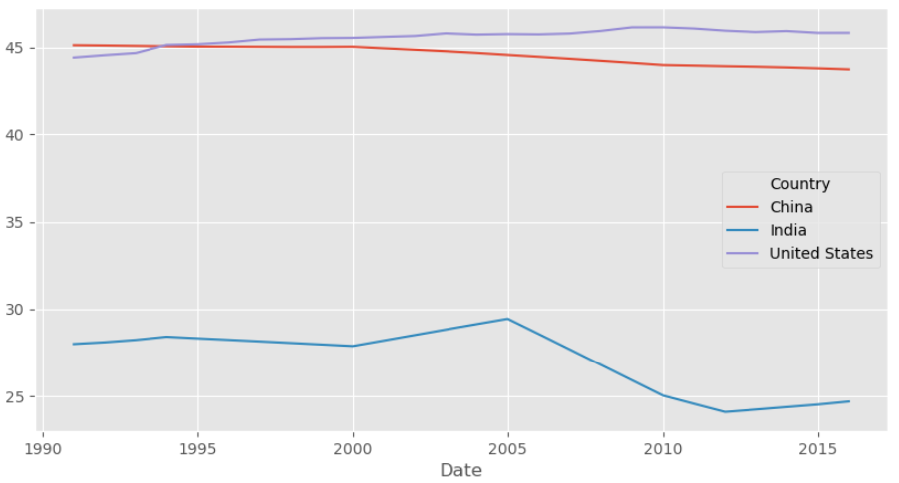

4: Gross Enrollment Ratio, tertiary

The gross enrolment ration, or GER, at the tertiary level here, indicates what would be suspected. That resource rich US sees about 80% of its students enrolling in colleges and higher education. That trend is yet to accelerate in the Eastern world. However, as it grows, the proportion of the population enrolling in higher education or specialized schooling nears 25% for India, and 45% for China.

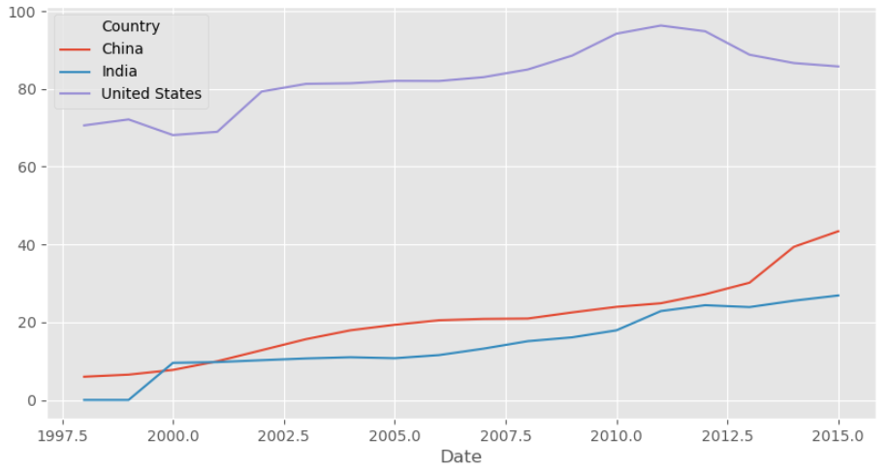

5: School Life Expectancy, Primary

One of the more sensational variable names, the school life expectancy is a measure of the time a student can be suspected to survive in school. In a sense it is a type of survival analysis performed by sociologists. All fall within the 5 to 6 year range.

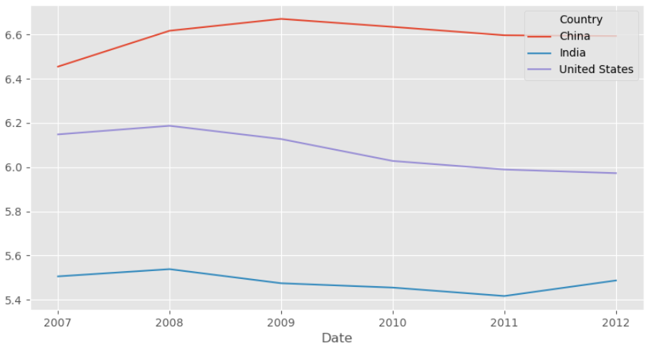

6: School Life Expectancy, Secondary

A divergence in the school life expectancy begins to appear in the secondary schooling level. However, as time progresses, we see India and China closing the gap, with China nearly catching up to the US, and India leveling off in recent years.

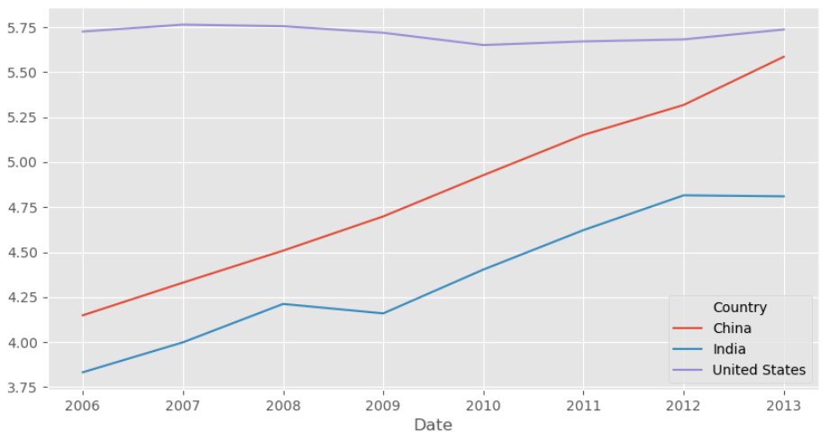

7: School Life Expectancy, Tertiary

Finally, the gap in school life expectancy remains more pronounced at the higher education level. With a delta of about 3.5 years between India and China the lower end of the spectrum – expecting about a years and a half worth of survival in tertiary education, and the US – looking at roughly 5.

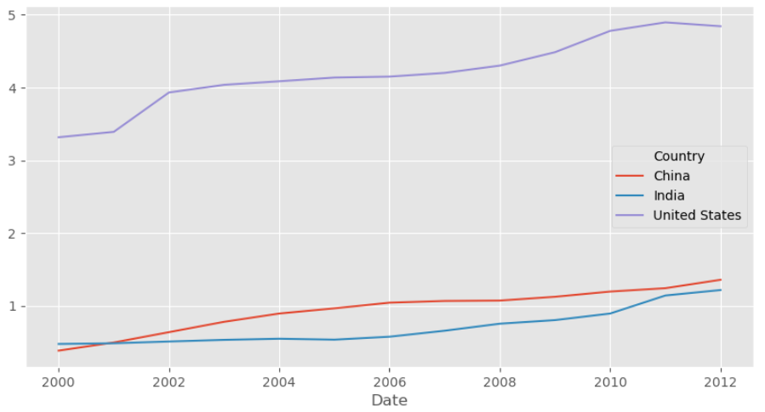

8: Tertiary Graduation, Numbers

China has been graduating a whole lot more students at the tertiary level in recent years. This, taken together with the higher enrolment ratios shows promising trends for China’s tertiary education.

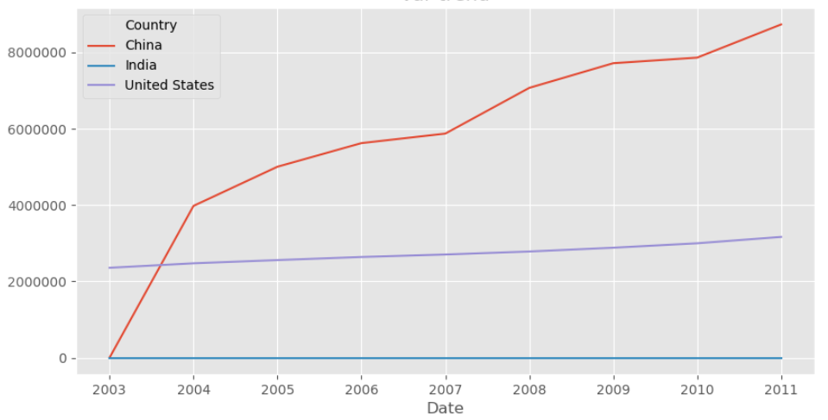

9: Population Growth

In one of India’s more commendable achievements, wading through a messy democracy, it has managed to lower its population growth statistics by a larger amount than both the US and China. This is surprising given its large population numbers, and is absolutely necessary in order to achieve a better distribution of education expenditure in time to come.

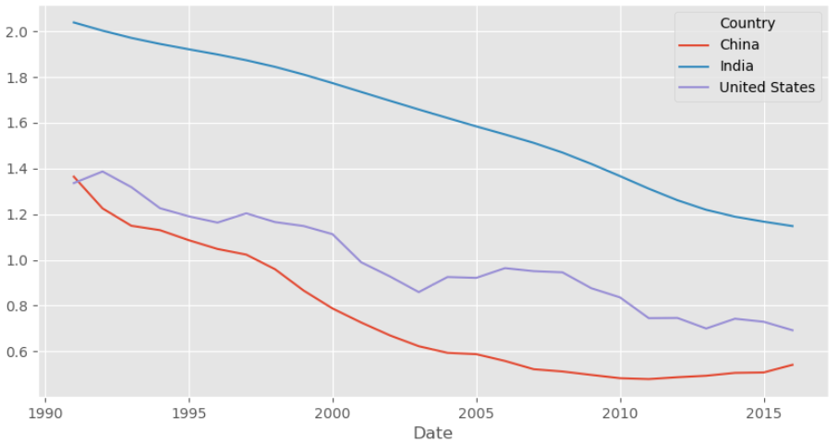

10: Mortality, per 1000

In step with its declining population growth, India’s mortality rates have come down dramatically from over 120 per 1000 to about 60 today. China and the US have managed to contain their mortality statistics per 1000 at a much lower level, hovering at around 10 per 1000.

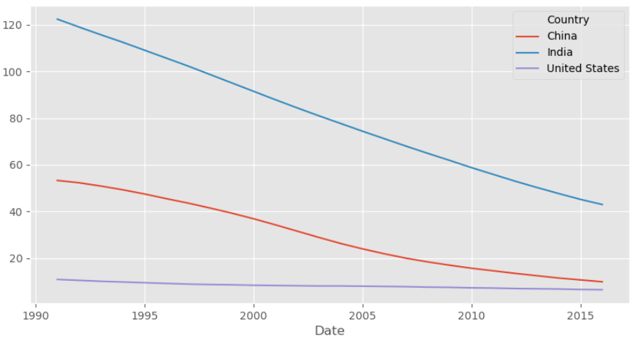

11: GDP per capita, in USD

And lastly, the statistic at which the US far outstrips the two eastern behemoths, the GDP per capita, measured in US Dollars. The US’s economy glides at about 60,000 per capital far above India and China’s 10,000 per capita.

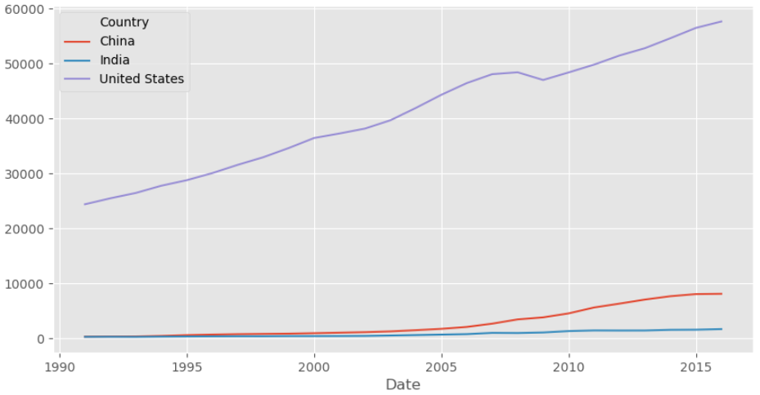

While the US may be contented gliding above the pack, there is a different satisfaction in knowing we have worthy competitors. But also in knowing that others are well while we are as a whole.